**Power BI Assignment 4**

1. Make a simple dashboard and show columns, bar charts, line charts, and area charts.

Answer: 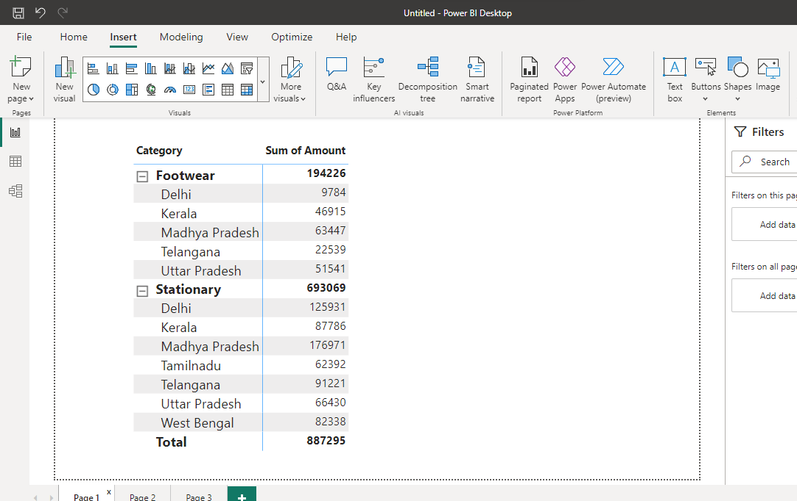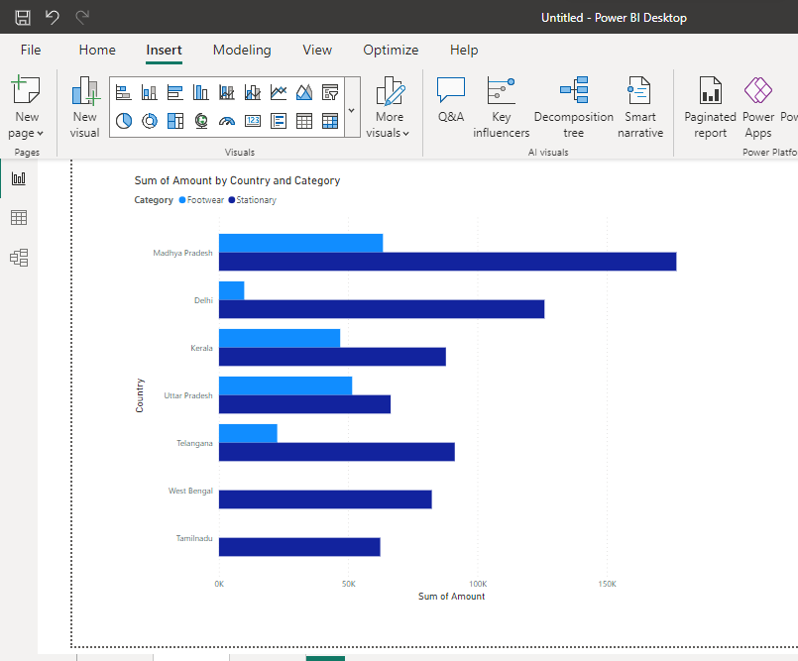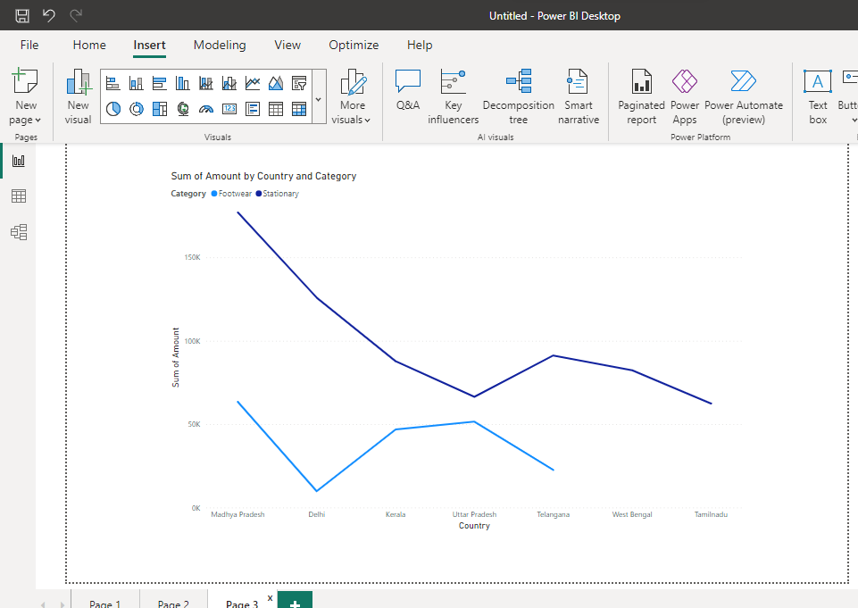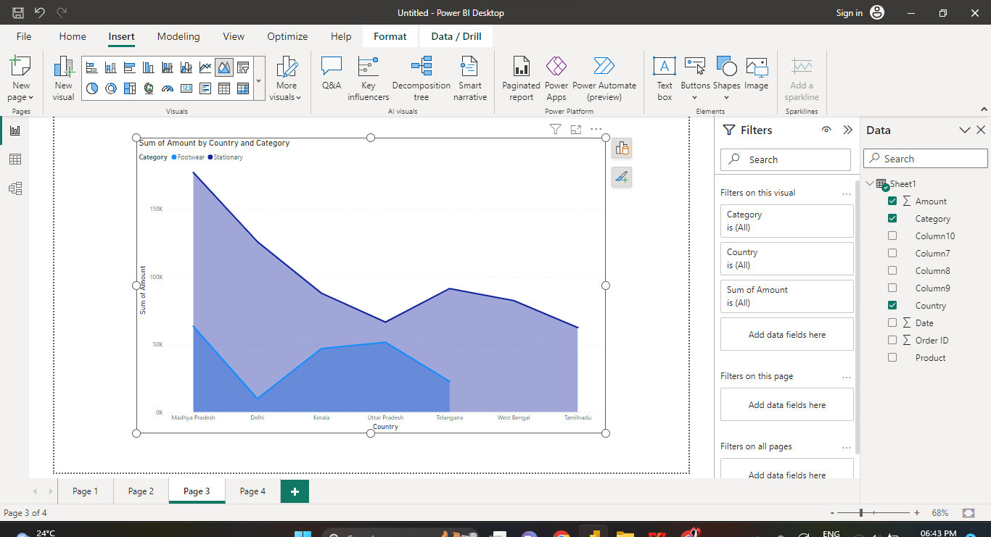

1. Make a simple dashboard and show combination, Scatter, Shape, and Treemap charts.

Answer:

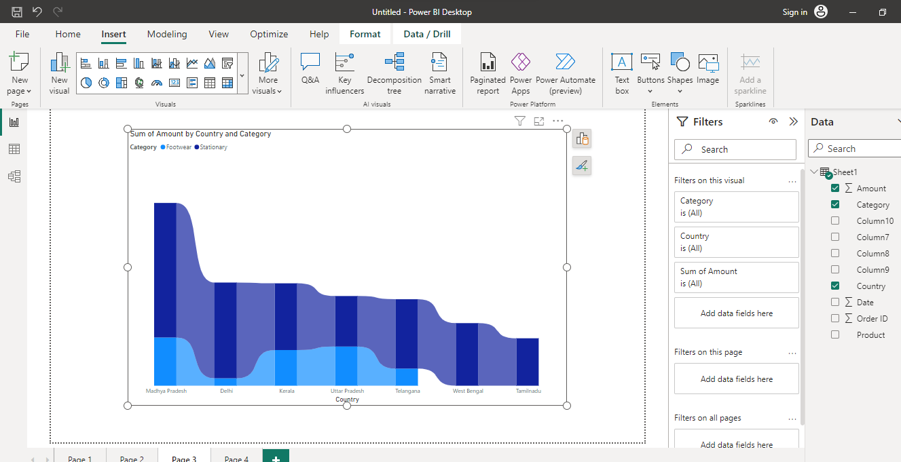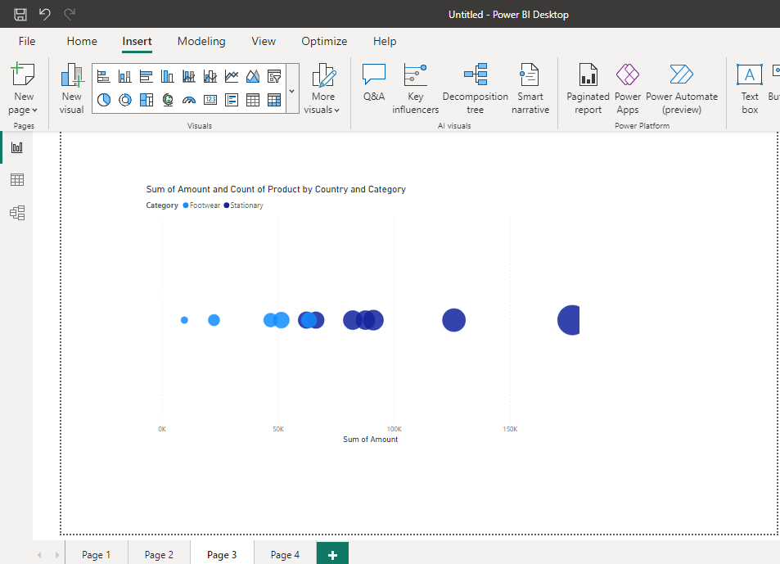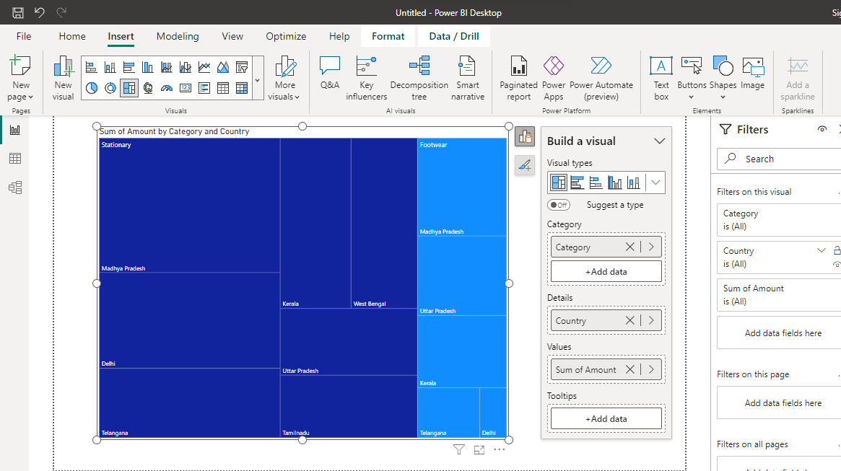

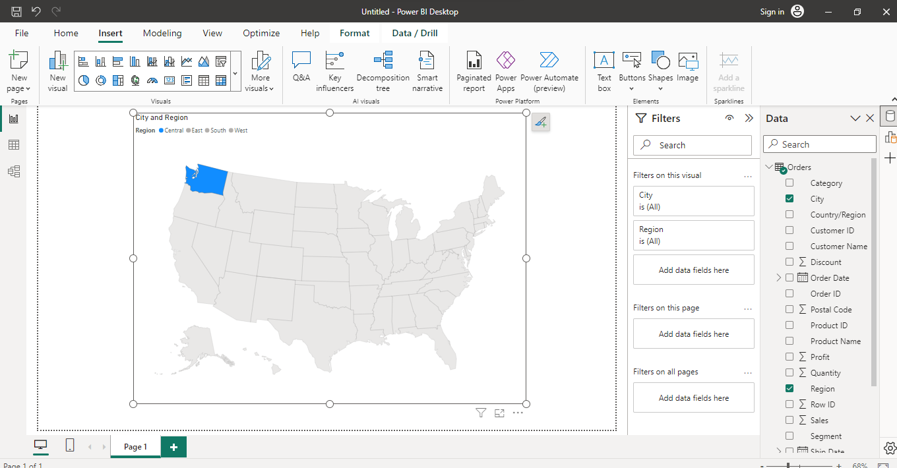

1. Make a dashboard and show 2 maps visualization i.e. basic map and filler maps.

Answer: 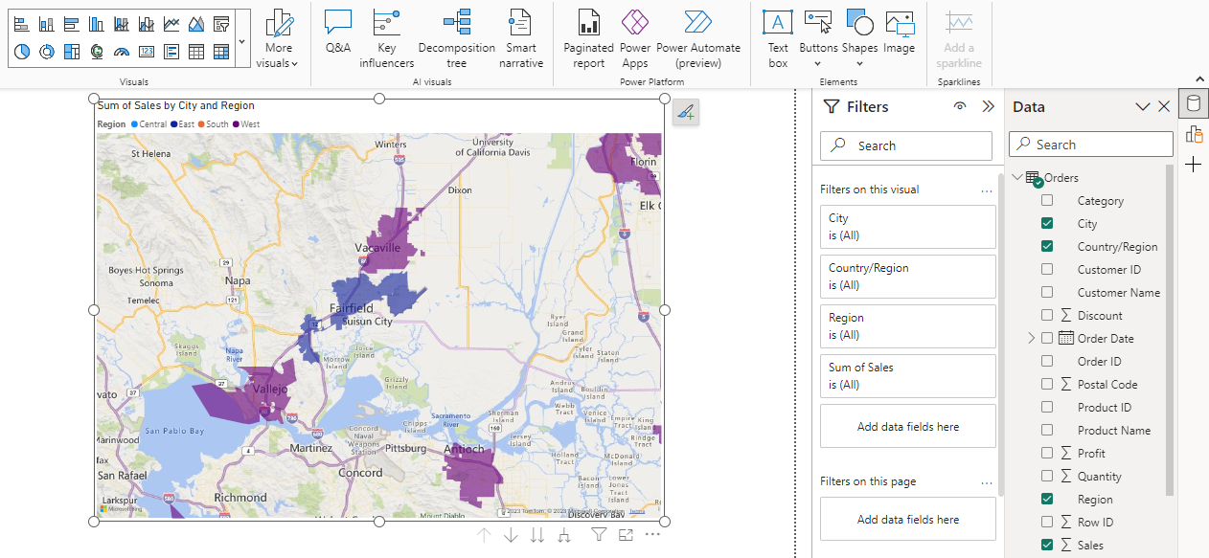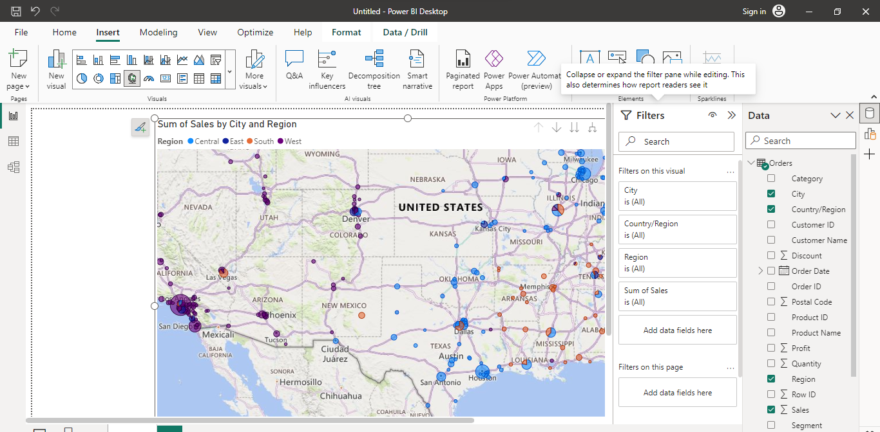

1. Create a report which has:

Bar chart

Card visualizations

Combo chart visualizations

Matrix visualizations

Column chart visualizations

guide: Sales data can be used

Answer: 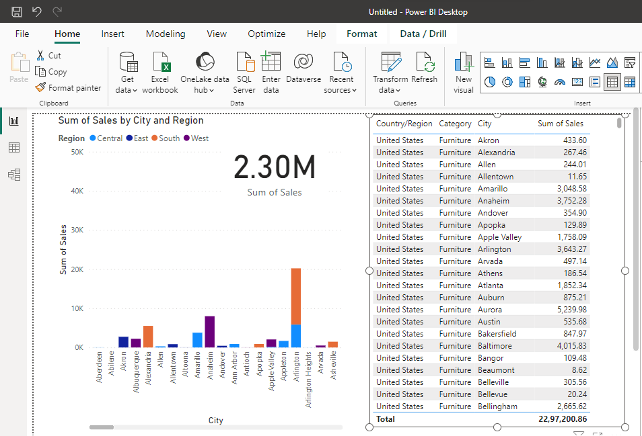

1. Make a report to analyze product sales using treemap visualization.

Answer: 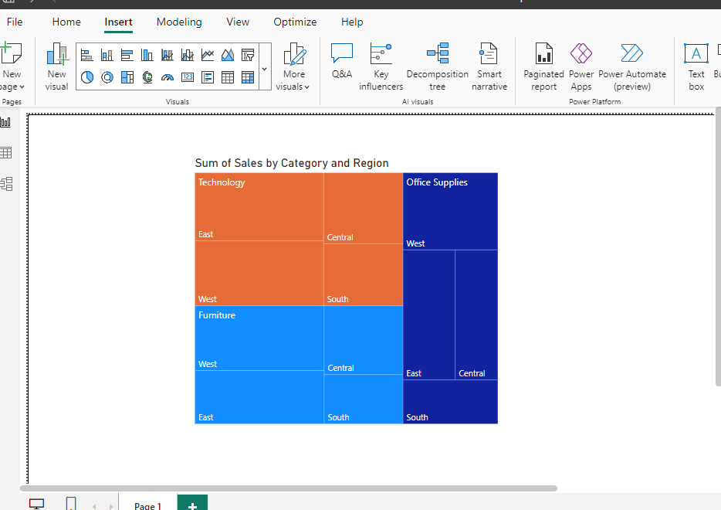

1. Make a dashboard on sales data (Minimum 4 tiles).

Answer: 